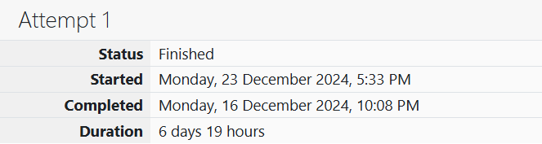

ROLL NO.: 241801281

NAME: SUJITHA NEELAKANDAN VIGNESHWARI

WEEK 02-01:

1.OBJECTIVE:

Many people think about their height in feet and inches, even in some countries that primarily use the metric system. Write a program that reads a number of feet from the user, followed by a number of inches. Once these values are read, your program should compute and display the equivalent number of centimeters.

CODE:

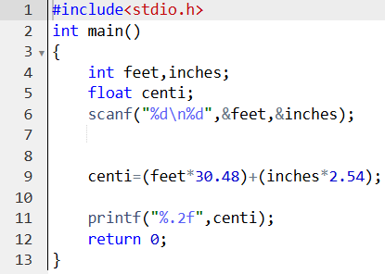

OUTPUT:

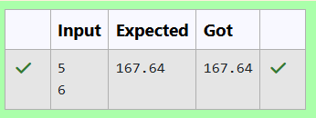

2.OBJECTIVE:

Create a program that reads two integers, a and b, from the user. Your program should compute and display: • The sum of a and b • The difference when b is subtracted from a • The product of a and b • The quotient when a is divided by b • The remainder when a is divided by b

CODE:

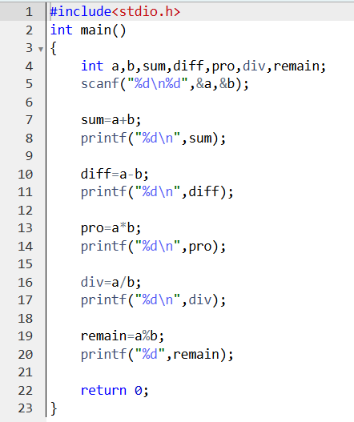

OUTPUT:

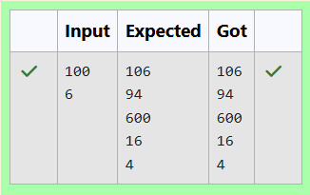

3. OBJECTIVE:

A bakery sells loaves of bread for $3.49 each. Day old bread is discounted by 60 percent. Write a program that begins by reading the number of loaves of day old bread being purchased from the user. Then your program should display the regular price for the bread, the discount because it is a day old, and the total price. Each of these amounts should be displayed on its own line with an appropriate label. All of the values should be displayed using two decimal places.

CODE:

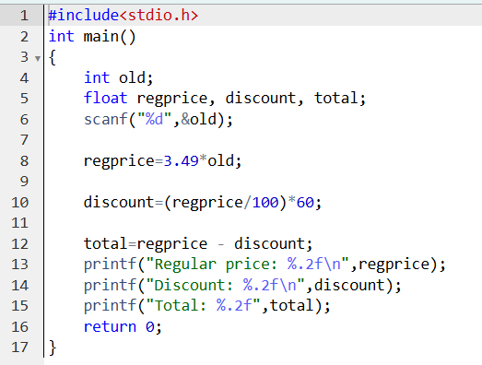

OUTPUT:

